Name: Kashif Hafeez
ID: F2024376314
Teacher: Sir Arman Sohail
Subject: OOP
Section: A1
Topic: Hotel Management System

Project Report: Hotel Management System

Introduction:
This project is a console-based Hotel Management System designed using Object-Oriented Programming (OOP) principles in C++. The system allows for room bookings, customer management, billing, and administrative controls, all while demonstrating the use of abstraction, inheritance, polymorphism, composition, exception handling, and file handling.
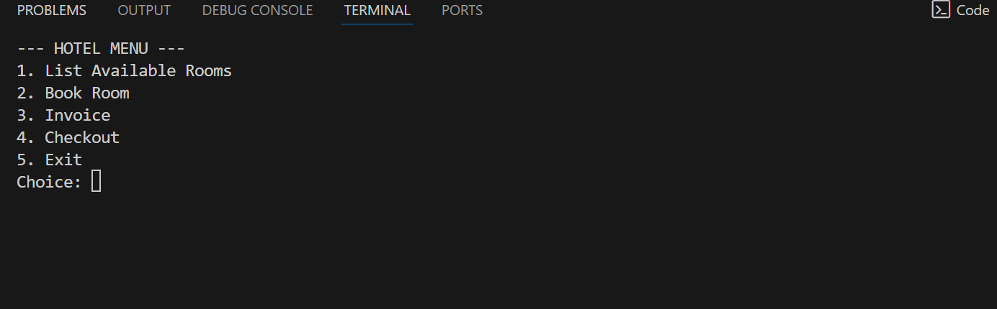

Key Functionalities Implemented:
- Room Booking and Management:
  - Room categories: Standard, Deluxe, Suite
  - Each with unique features like Smart Lock, Ocean View, and Mini Bar
  - Dynamic room pricing with additional taxes/service fees
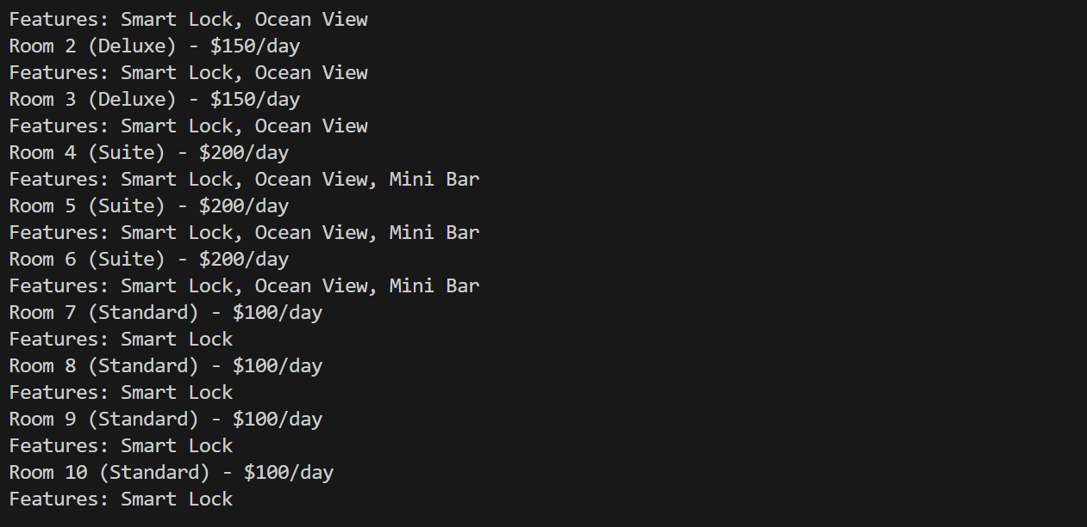
- Customer Handling:
  - Personal details, ID verification, loyalty points

  - Booking linkage and duration tracking

- Billing System:
  - Tiered billing based on room type
  - Loyalty discount

  - Dynamic invoice generation
- Admin Controls:
  - Login-based access control
  - Add/remove/view rooms
  - Checkout system to mark rooms available again

- Persistence:
  - Room status maintained during session
  - Booking data saved for future retrieval (extendable via file handling)
- Exception Handling:
  - Handles invalid inputs (e.g. text in number fields)
  - Booking clashes and validations
- OOP Features Used:
  - Abstract Classes & Pure Virtual Functions: Used in the Room class and overridden by Standard Room, Deluxe Room, Suite Room
  - Encapsulation: Private data members with public functions
  - Inheritance & Polymorphism: Room classes and Service interfaces
  - Composition: Hotel class managing rooms, bookings, customers

UML Class Diagram:
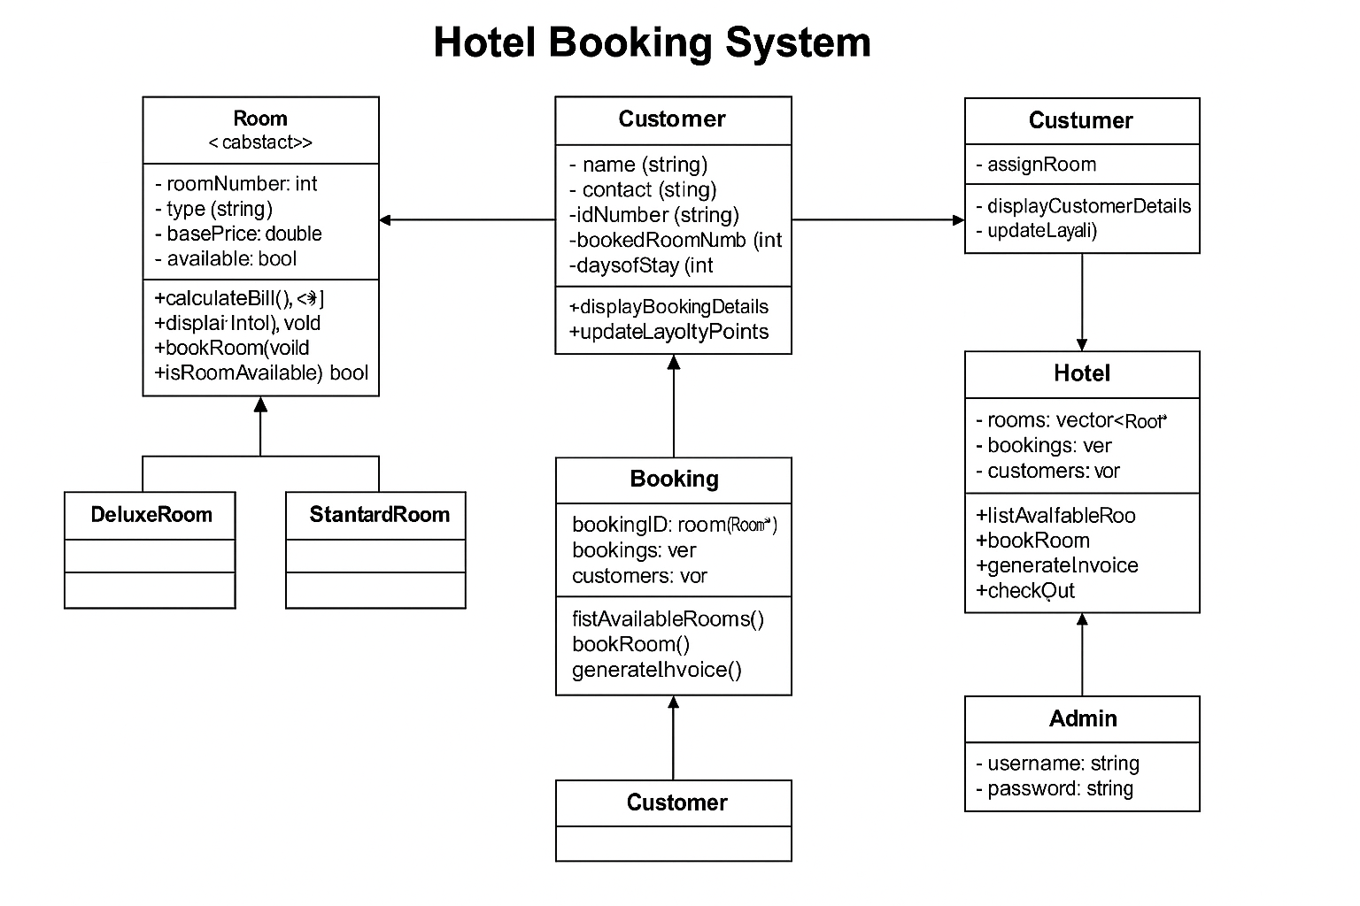

Highlights:
- Easy-to-use console interface
- Reusable and scalable code
- Demonstrates real-world application of OOP

Conclusion:
The Hotel Management System project is a successful demonstration of advanced OOP concepts applied in a real-world simulation. It not only manages hotel operations but also ensures modularity and scalability for future enhancements such as GUI, file-based persistence, and networking.

Submitted By: Kashif Hafeez
ID: F2024376314
Submission: 22 June 2025

